**Farmie**

**Admin page:**

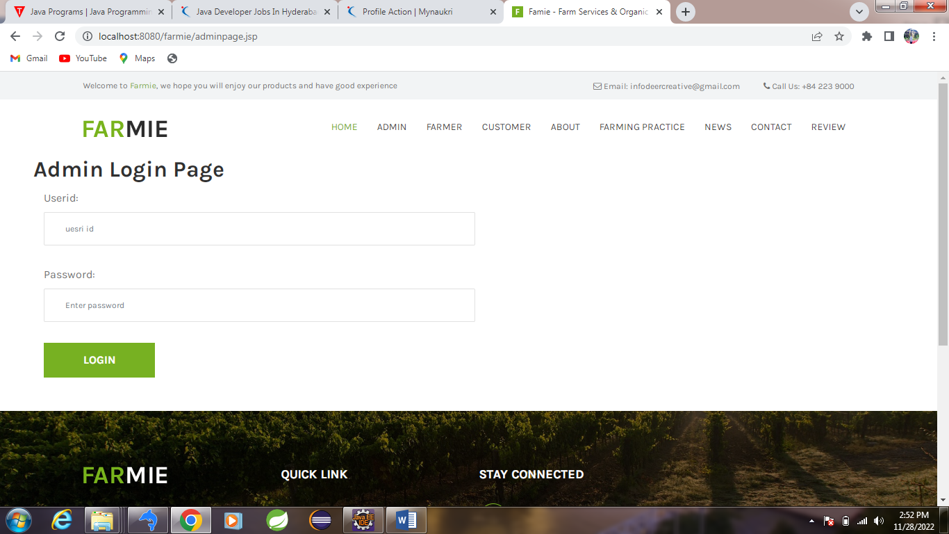

**Code:**

<%@ include file=*"header.jsp"* %>

<div class=*"ml-5"*>

<h2>Admin Login Page</h2>

<div class=*"contact-form-area"*>

<form action=*"admindata.jsp"* method=*"post"*>

<div>

<div class=*"col-lg-6"*>

<label>Userid:</label>

<input type=*"text"* class=*"form-control"* name=*"userid"* placeholder=*"uesri id"* required>

</div>

<div class=*"col-lg-6"*>

<label>Password:</label>

<input type=*"password"* class=*"form-control"* name=*"password"* placeholder=*"Enter password"* required>

</div>

<div class=*"col-12"*>

<button type=*"submit"* class=*"btn famie-btn"*>Login</button>

</div>

</div>

</form>

</div>

</div>

<br><br>

<%@ include file=*"footer.jsp"* %>

**Admin Home:**

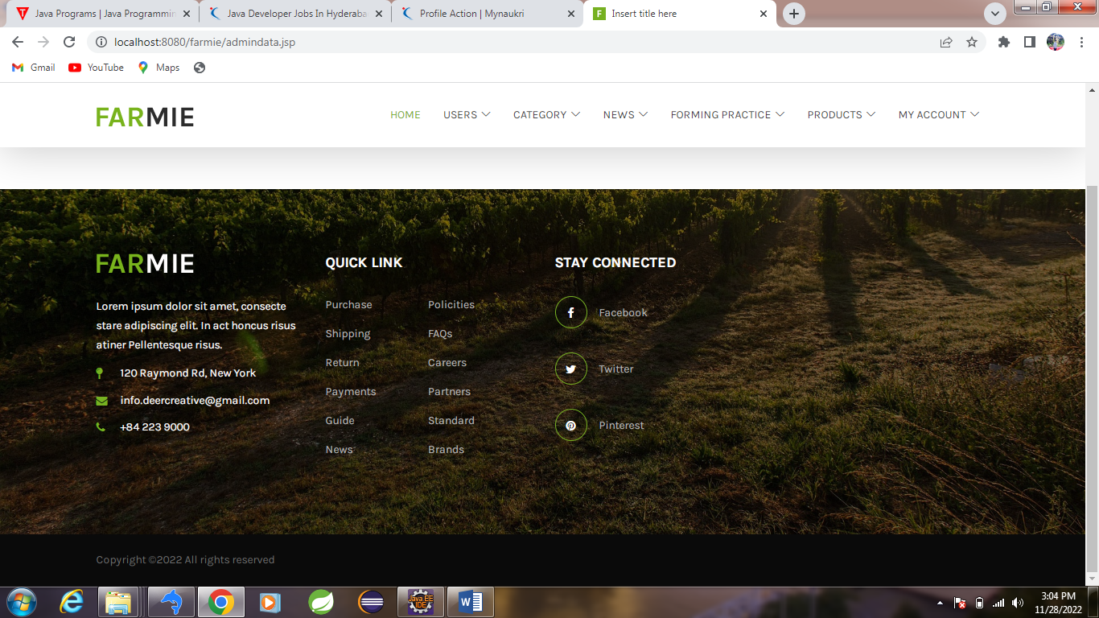

**View formers:**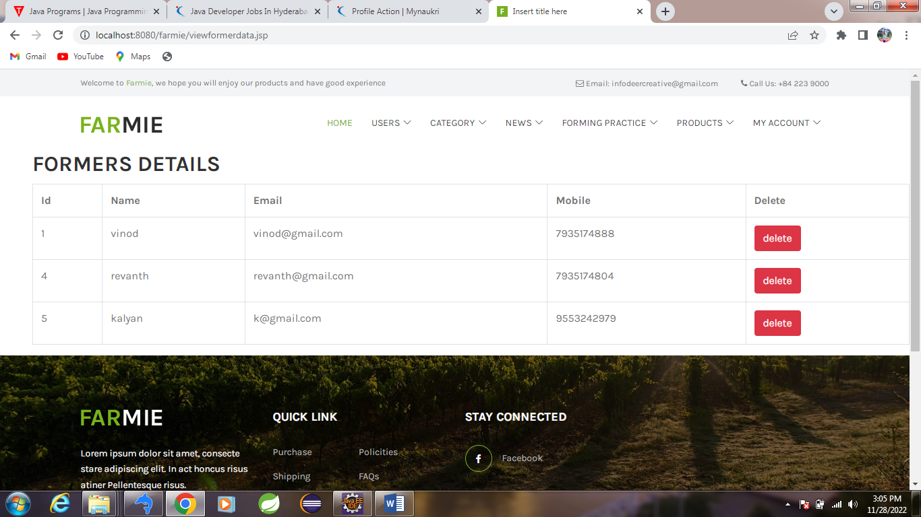

**Code:** <%@ include file=*"adminheader.jsp"* %>

<%@ include file=*"connect.jsp"* %>

<div class=*"ml-5"*>

<h2>FORMERS DETAILS</h2>

<%

**try**

{

Statement st=con.createStatement();

ResultSet rs=st.executeQuery("select * from former");

**int** count=0;

out.println("<table class='table table-bordered'>");

out.println("<tr>"+"<th>"+"Id"+"</th>"+"<th>"+"Name"+"</th>"+"<th>"+"Email"+"</th>"+"<th>"+"Mobile"+"</th>"+"<th>"+"Delete"+"</th>"+"</tr>");

**while**(rs.next())

{

count++;

out.println("<tr>");

out.println("<td>"+rs.getInt(1)+"</td>"+"<td>"+ rs.getString(2)+"</td>"+"<td>"+rs.getString(3)+"</td>"+"<td>"+rs.getString(5)+"</td>");

out.println("<td>"+"<a class='btn btn-danger' <a onclick='return validate();'href='formerdelete.jsp?Id="+rs.getInt(1)+"'>delete</a>"+"</td>");

out.println("</tr>");

}

out.println("</table>");

**if**(count==0) {System.out.println("no records found");

}

st.close();

st.close();

con.close();

}

**catch**(Exception e)

{

e.printStackTrace();

}

%>

</div>

<script>

**function** validate(){

**if**(confirm("do you want to delete")){

**return** **true**;

}

**else**{

**return** **false**;

}

}

</script>

<%@ include file=*"footer.jsp"* %>

**Add news:**

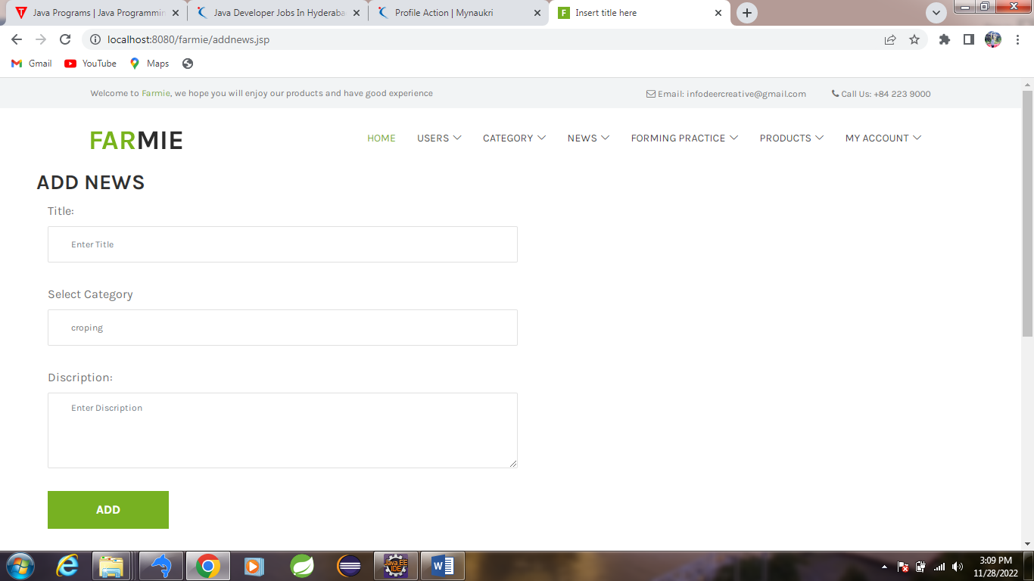

**Code:**

<%@ include file=*"adminheader.jsp"* %>

<%@ include file=*"connect.jsp"* %>

<div class=*"ml-5"*>

<h3>ADD NEWS</h3>

<div class=*"contact-form-area"*>

<form action=*"addnewsdata.jsp"* method=*"post"*>

<div>

<div class=*"col-lg-6"*>

<label>Title:</label>

<input type=*"text"* class=*"form-control"* name=*"title"* placeholder=*"Enter Title"* required>

</div>

<div class=*"col-lg-6"*>

<label>Select Category</label>

<select name=*"category"* class=*"form-control"* >

<%

**try**

{

Statement st=con.createStatement();

ResultSet rs=st.executeQuery("select title from category");

**while**(rs.next())

{

out.println("<option>"+rs.getString(1)+"</option>");

}

}

**catch**(Exception e)

{

e.printStackTrace();

}

%>

</select>

</div>

<div class=*"col-lg-6"*>

<label>Discription:</label>

<textarea name=*"dis"* class=*"form-control"* cols=*"30"* rows=*"10"* placeholder=*"Enter Discription"* required></textarea>

</div>

<div class=*"col-12"*>

<button type=*"submit"* class=*"btn famie-btn"*>ADD</button>

</div>

</div>

</form>

</div>

</div>

<br><br>

<%@ include file=*"footer.jsp"* %>

Add forming:

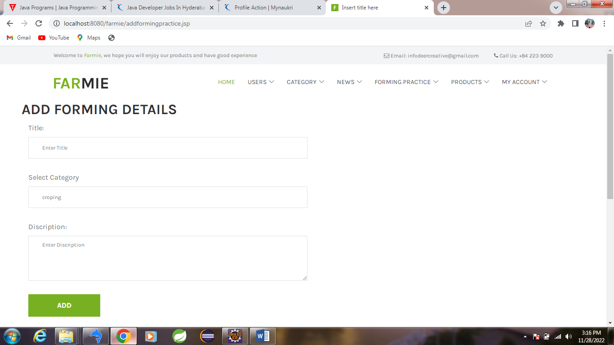

Code:

<%@ include file=*"adminheader.jsp"* %>

<%@ include file=*"connect.jsp"* %>

<div class=*"ml-5"*>

<h2>ADD FORMING DETAILS</h2>

<div class=*"contact-form-area"*>

<form action=*"addformingpracticedata.jsp"* method=*"post"*>

<div>

<div class=*"col-lg-6"*>

<label>Title:</label>

<input type=*"text"* class=*"form-control"* name=*"title"* placeholder=*"Enter Title"* required>

</div>

<div class=*"col-lg-6"*>

<label>Select Category</label>

<select name=*"category"* class=*"form-control"* >

<%

**try**

{

Statement st=con.createStatement();

ResultSet rs=st.executeQuery("select title from category");

**while**(rs.next())

{

out.println("<option>"+rs.getString(1)+"</option>");

}

}

**catch**(Exception e)

{

e.printStackTrace();

}

%>

</select>

</div>

<div class=*"col-lg-6"*>

<label>Discription:</label>

<textarea name=*"dis"* class=*"form-control"* cols=*"30"* rows=*"10"* placeholder=*"Enter Discription"* required></textarea>

</div>

<div class=*"col-12"*>

<button type=*"submit"* class=*"btn famie-btn"*>ADD</button>

</div>

</div>

</form>

</div>

</div>

<br><br>

<%@ include file=*"footer.jsp"* %>

Add products:

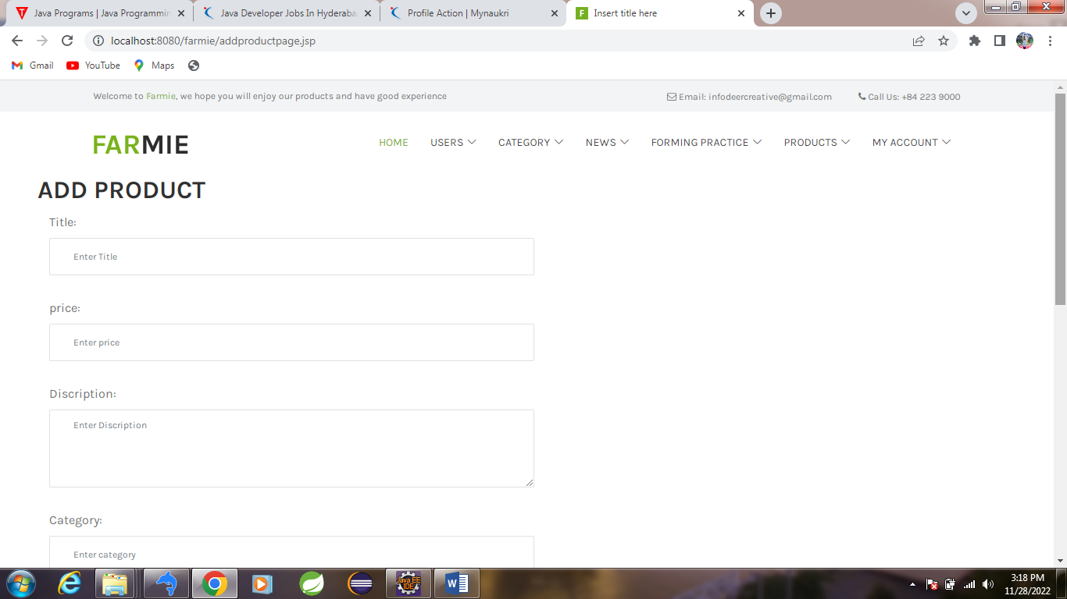

Code:

<%@ include file=*"adminheader.jsp"* %>

<div class=*"ml-5"*>

<h2>ADD PRODUCT</h2>

<div class=*"contact-form-area"*>

<form action=*"addproductdata.jsp"* method=*"post"*>

<div>

<div class=*"col-lg-6"*>

<label>Title:</label>

<input type=*"text"* class=*"form-control"* name=*"title"* placeholder=*"Enter Title"* required>

</div>

<div class=*"col-lg-6"*>

<label>price:</label>

<input type=*"number"* class=*"form-control"* name=*"price"* placeholder=*"Enter price"* required>

</div>

<div class=*"col-lg-6"*>

<label>Discription:</label>

<textarea name=*"dis"* class=*"form-control"* cols=*"30"* rows=*"10"* placeholder=*"Enter Discription"* required></textarea>

</div> <div class=*"col-lg-6"*>

<label>Category:</label>

<input type=*"text"* class=*"form-control"* name=*"category"* placeholder=*"Enter category"* required>

</div>

<div class=*"col-lg-6"*>

<label>Spl-Tag:</label>

<input type=*"text"* class=*"form-control"* name=*"spltag"* placeholder=*"Enter spltag"* required>

</div>

<div class=*"col-12"*>

<button type=*"submit"* class=*"btn famie-btn"*>ADD</button>

</div>

</div>

</form>

</div>

</div>

<br><br>

<%@ include file=*"footer.jsp"* %>

Former login:

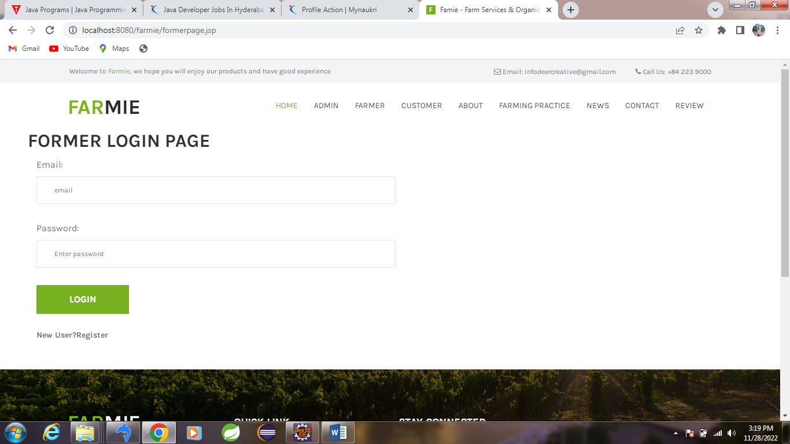

Add products:

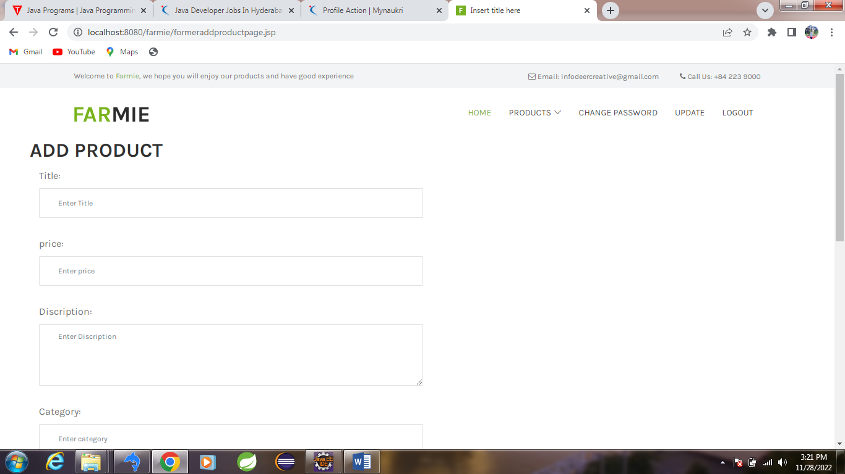

Buy products:

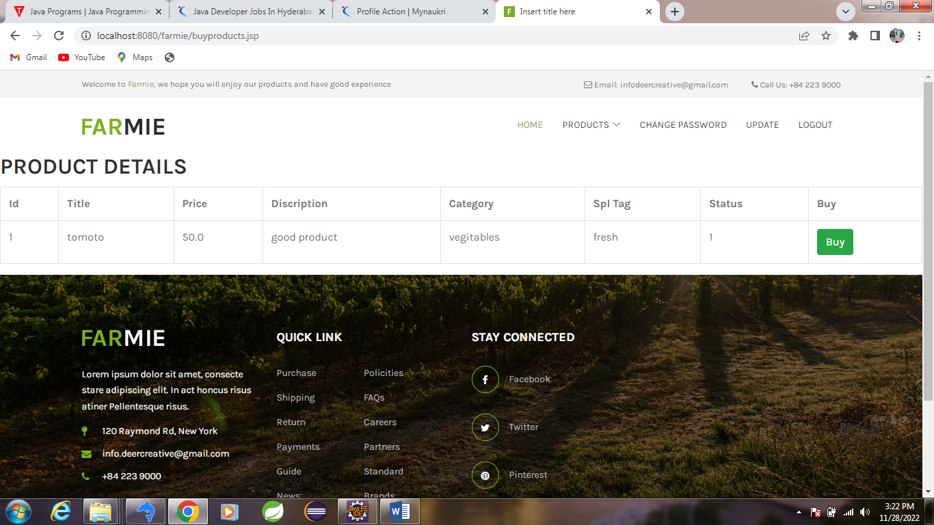

Customer page:

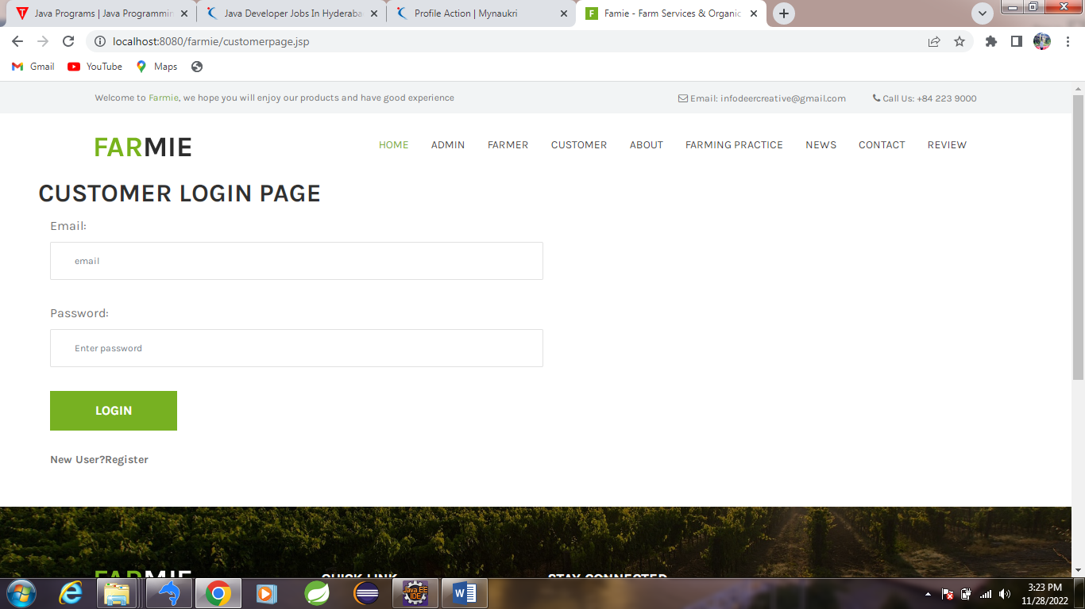

View products:

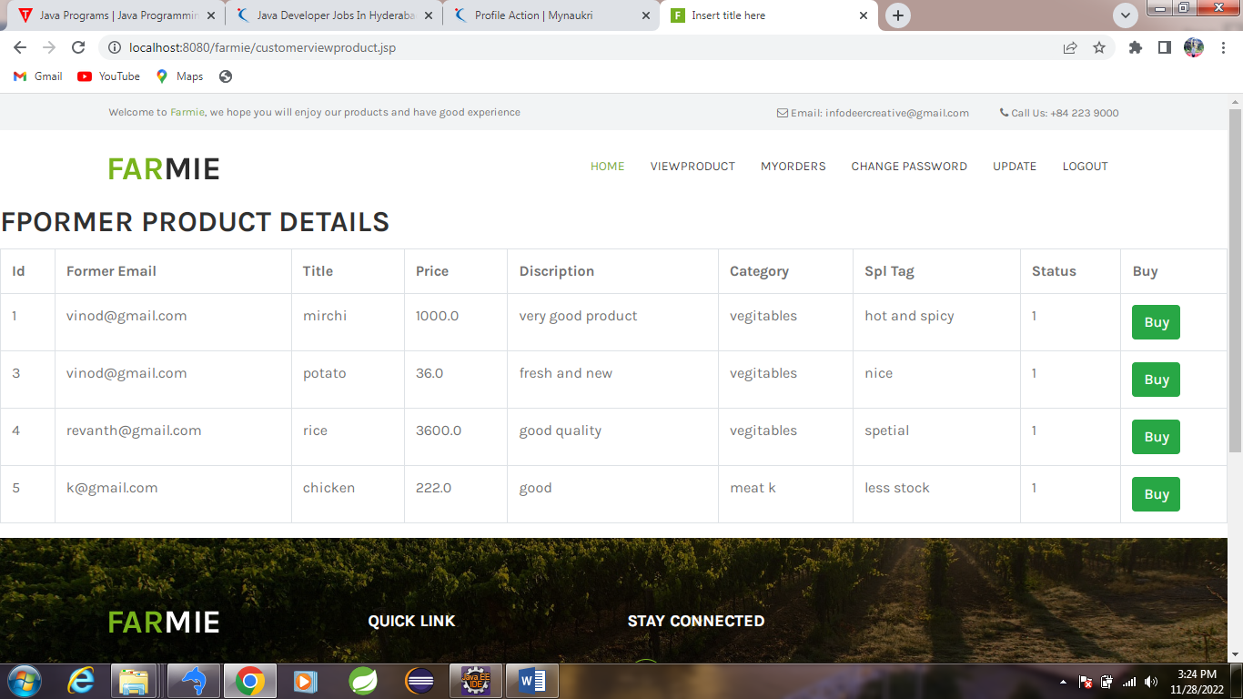

My orders:

